RTL Design of a 4x4 Multiplier on 7 segment display

Stage 1  
multiplier

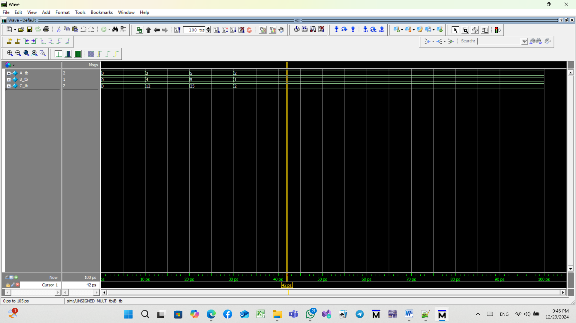

**Stage 2**

**Shift add3**

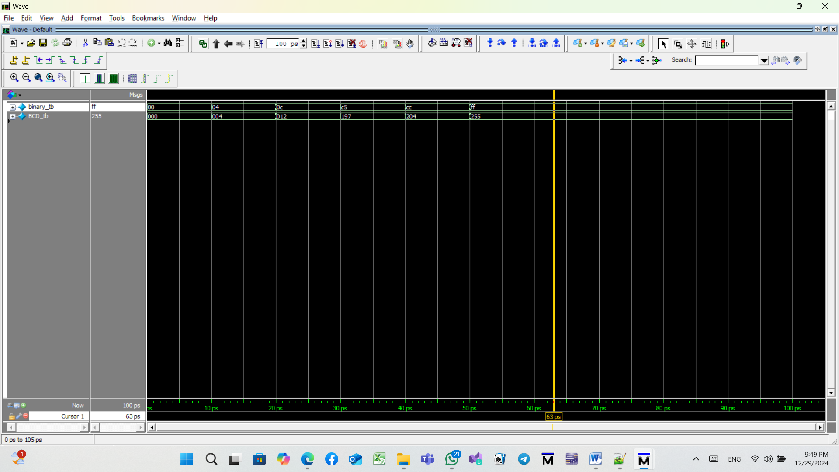

**Stage 3**

**Integrate the design**

